**POWER BI ASSIGNMENT-13**

**Use Case –** Working with tooltips

**Source –** Authors

**Analytics –** Create Tooltips

**Requirement**

Q1. Open the power bi file in the above folder. It shows the 100 bestselling books since 1998:

Step-1. Creating tool tips page

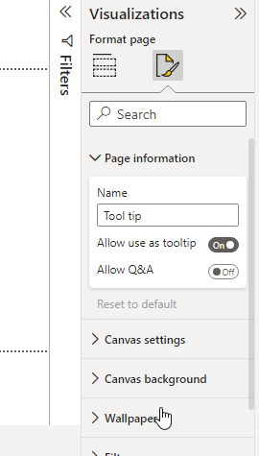

Step-2. Now we change the page size to tool tips:

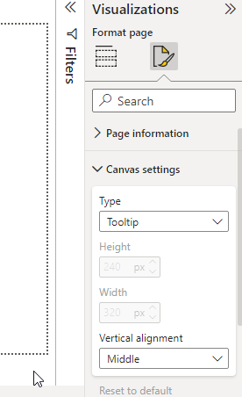

Step-3. Inserting values to the tool tips and applying bar chart visual to it

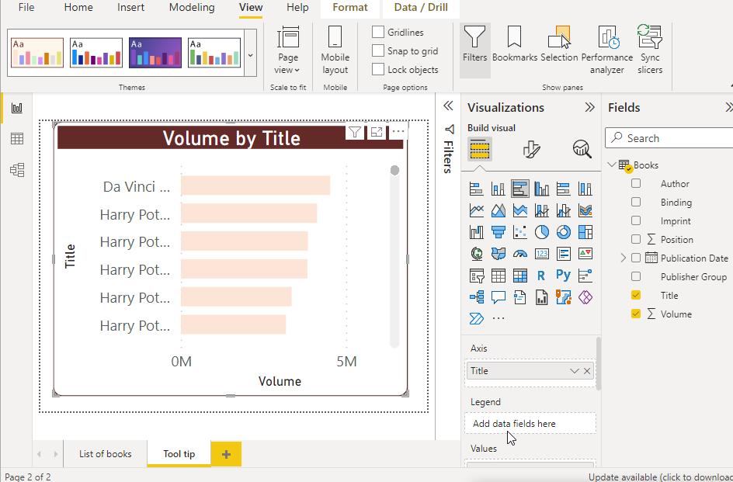

Step-4. Assigning tool tip to the report page.

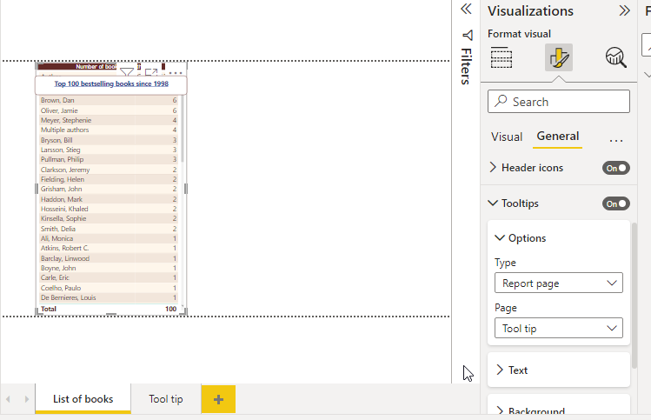

Save and publish in powerbi service as Authors info

